Information on Grad Write-Ups
For Yearbook 2021

Grad Write-Ups
Graduates, you will have the opportunity to do a traditional write-up or have a chance to express yourself in a variety of ways that will help you remember your time in high school. Here are a couple of guidelines to follow:

All graphics/content is to be:
- No more than 400 characters (including punctuation and spaces).
- No mention of partying, drinking, drugs, illegal activity, etc. No swear words, suggestive language or rude comments permitted.
- If you are copying a poem/song or speech you will need to include the author/poet.
- Make sure all information is appropriate for publication.
- No links to social media.
- Please proofread your final copy.

You may hand in your write-ups on the page provided to the office or if you have typed it up you may email your write-up to AJSGrad@eips.ca. Deadline is Friday, April 9, 2021.

Below is an example of how it will appear in the yearbook.

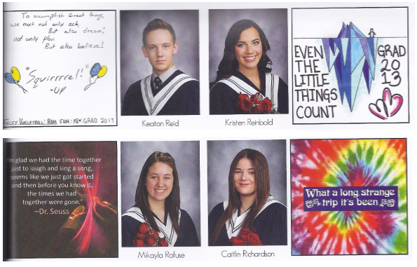

Grad Write-Ups for Yearbook 2021
Name: _____________________________________________________________
PLEASE print your first and last name clearly. Write your name above as you want it to appear in the yearbook. Example: if your name is Matthew Smith and want it to appear as Matt Smith then you would write Matt Smith above.
Either fill the large or smaller box below remembering that the larger box will be scaled down to size and so the writing must be legible once this is done. Fill the entire space. Do not write outside the lines. Use dark ink/marker (not pencil) – something that is easy to read. You may use a variety of colours.
Hand in to the office or email write-up to AJSGrad@eips.ca before Friday, April 9, 2021!
Actual size in Yearbook
If you have questions, please see the office staff.

